HPS beamline commissioning document v1.0

October 20, 2014

Authors: Ken Moffeit, Stepan Stepanyan, and Takashi Maruyama

Document Contact: Takashi Maruyama

**Beam:** Beam energy 2.2GeV (+/-). Beam current as low as possible to give good readings on beam diagnostics instrumentation (~5 nA).

**For location of beam line element please consult beamline drawings on Figure 4 and Figure 5 in Appendix.**

1. **Beam to Hall-B tagger dump – Accelerator Operations**

1. Hall-B tagger magnet and other magnets in beam line are ON with current appropriate to actual beam energy.
2. Diagnostics at tagger dump live and checked out.
3. Verify that beam delivery is interlocked with tagger magnet.

**Accelerator Operations:**

1. Define the incoming trajectory of the beam and initiate feedback loop.
2. Bring beam to the tagger beam line dump centered appropriately.
3. **Harp Wire scan:** Accelerator Operation and HPS: Measure beam size using two harp wire scanners - one in the tunnel (harp 2C21) and second before the Hall-B tagger magnet (the tagger harp, 2C24). Measure beam size and position at <10 nanoamps (current limit for harp) with beam going to tagger dump. Adjust beam line quads upstream of tagger magnet to obtain desired beam profile.
4. **Harp Wire scans with large dynamic range**: Beam fixed with beam current < 10 nanoamps. Perform Harp wire scans with “**large dynamic**” range harp to verify beam tails.
5. **Beam current scans:** Measure beam halo as a function of beam current from 1 to 200 nanoamps.
6. Position Harp wire away from core of beam and vary beam current. Set Harp wire away from core of beam, e.g. 100 microns (~2 sigma) above and below beam center. Measure halo counter PMTs as a function of beam current. Verify scaling of beam tails with increasing current. (Note that the halo counter PMTs will saturate if the beam core at 200 nanoamps hits the Harp wire.)
7. Do beam current scans with the Harp wire in at least two different positions, for example, at 100 microns and 150 microns (~2 and 3 sigma). But the positions will depend on the Harp scan result at low current described above.
8. If a long halo tail is measured in step 7 above, perform beam current scan at 250 microns and 500 microns (~ 5 and 10 sigma).
9. **HPS Pre-setup before bringing beam to alcove and dump**
10. **Silicon Detector**: Voltages off. Upper and lower moveable silicon detector elements retracted.HPS wiresin silicon detector retracted**.** Silicon detector cooling system on and temperatures monitored.
11. **HPS production Target** retracted out of beam path.
12. **HPS Protection Collimator** retracted out of beam path.
13. **Ecal detector** voltages off with cooling, etc. operational.
14. **Chicane magnets** off.
15. **Beam halo counters** and other **beam diagnostic** instrumentation ON.
16. **Beam to alcove and dump**

1. From BPMs upstream of tagger magnet verify beam position and angle are appropriate for sending beam to alcove and Hall B dump.
2. Beam current ~1 nanoamps.
3. Consider using CEBAF pulsed mode at 60 Hz for initial optics tuning.
4. After an acceptable beam profile and stability is achieved turn off tagger magnet and degauss. Reset beam interlock to the tagger magnet.
5. Verify that the beamline vacuum is correct, BPMs, halo monitors, etc. operational.

**Accelerator Operations:**

1. **Quad doublets** on 2H00 guider (MQA2H00.K1 and MQA2H00A.K1) at desired current.
2. **Bring beam through Hall B beam line** and HPS system in alcove to dump.
3. View beam with **insertable beam viewer** downstream of the HPS and measure the beam current on Faraday cup, ~ 40 meters downstream of tagger magnet.
4. Set fast beam shutoff trip points.
5. Verify that the **Beam Abort System** works correctly by moving harp wire on girder 2H00 into beam. Beam abort system should be OFF when we conduct harp scans.
6. **Measure beam position at BPMs** on guider 2H00 near tagger magnet.
7. **Measure beam profile and position with Harp** located on guider 2H02 just before first chicane magnet. Verify beam size is as expected. Adjust Quad doublets (MQA2H00.K1 and MQA2H00A.K1) to achieve required beam profile.
8. **HPS and Accelerator Operations – center beam in Ecal vacuum chamber**

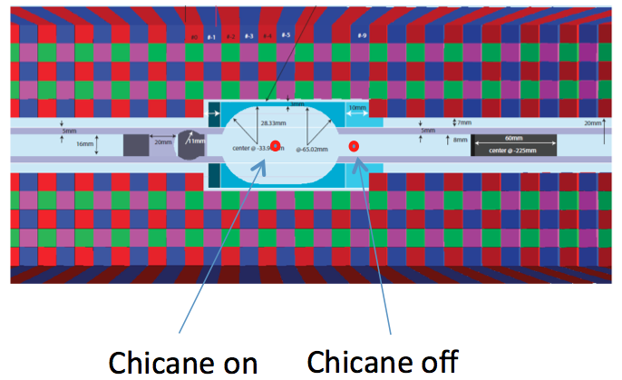

Figure 1 Beam positions at the upstream face of the ECal vacuum chamber.

**Vertical centering in Ecal vacuum chamber**

1. Beam current less than 5 nanoamps
2. Chicane magnets off.
3. ECal detector ON. Halo counters downstream of HPS ON.
4. With vertical corrector magnets on girder 2H00 (near tagger magnet) center beam vertically in narrow part of Ecal vacuum chamber (see figure above - must be done with chicane magnet currents off.) Verify beam is located appropriately at dump.
5. Use ECal and halo monitors downstream of chicane magnets to detect walls of vacuum chamber above and below the beam using tails of beam.

**Horizontal centering in Ecal vacuum chamber**

1. **Set chicane magnets to correct currents** for beam energy and return beam to dump. Verify the beam position is okay on the Insertable Beam Viewer.
2. In operation below do not change the current in the HPS analyzing magnet.
3. **HPS production target IN** (target should be in place for horizontal centering.) With HPS target in a gamma beam and coulomb scattered electron beam are produced.
4. **ECal detector ON.**
5. **Downstream halo counters** ON.
6. **Use horizontal corrector magnets** on girder 2H00. Move the horizontal position to achieve minimal rates in the ECal with electron beam going to dump.
7. Using coulomb scattered beam electrons from target collect data in Ecal detector and determine horizontal and vertical position of beam in Ecal vacuum chamber (this is not a precision measurement, but should be good to a mm or so - we should aim just to get the beam through with minimal rates on ECal.)
8. If possible verify that the **photon beam** (from HPS production target) travels to the gamma beam dump.
9. Verify position of beam at beam dump is still within tolerance.
10. **HPS and Accelerator Operations – center beam in HPS silicon detector.**

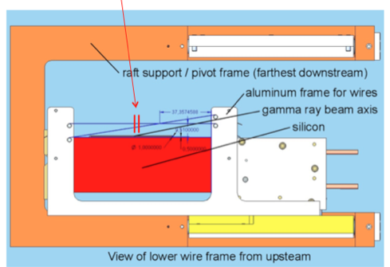

Figure 2 SVT Layer 1 and SVT wires (bottom half).

1. Beam current less than 5 nanoamps.
2. Ecal voltage on.
3. HPS production target out.
4. Downstream halo counter ON. Note that the ECal response will measure when the beam is hitting the silicon detector wires.
5. Move **silicon detector wires** in silicon detector to **center of HPS** **silicon detector**.
6. Do at least two wire scans. Each scan should cover both horizontal and tilted wires.
7. **Center beam vertically** on silicon detector wires by adjusting upstream vertical corrector magnets on 2H02.
8. Verify beam position is okay at the beam dump.
9. **Center beam horizontally** on silicon detector wires: adjust 2H00 and 2H02 horizontal corrector magnets to get beam at the correct horizontal position relative to the SVT and within tolerance at the dump (~1 mm).
10. Verify that the beam is still horizontally and vertically centered in Ecal vacuum chamber within acceptable limit. Verify that the beam is still located appropriately at the dump.
11. **Position HPS Protection Collimator**



Figure 3 SVT protection collimator stick.

1. Find location of beam at **HPS protection collimator** with HPS Protection Collimator wire.
2. With beam off move HPS Protection Collimator ladder to have 3mm gap centered on beam.
3. Fine tune HPS PC vertical position by moving HPS Protection Collimator ladder up and down.
4. **Setup trip levels for BLMs and halo counters in FSD.**
5. HPS target is out.
6. Downstream halo counters ON.
7. Move beam vertically (both up and down directions must be tested) using vertical correctors on 2H00 and record current on BLMs and rates on downstream halo counters.
8. Set trip limits on BLM and halo counters in FSD such that FSD will be initiated when beam moves vertically from its nominal position more than 0.5mm.
9. **Tests after beam through HPS is established, chicane currents are set and rates on halo counters are as expected.**
10. HPS target is out.
11. Downstream halo counters ON.
12. Verify that Fast Beam Shutoff is active.
13. SVT is retracted and voltages OFF.
14. Park Y-wire of the harp just upstream of the first Frascati at some distance (say 300 micron) from the beam center.
15. Run beam at nominal current (200 nA) for several hours, and read and store rates of the halo counters after the wire at high frequency (say 1 - 10 kHz). This should be repeated for both beam up and beam down positions.
16. The expected average beam trip rate is 10/hour, running a shift (4 hours per position) should give us good understanding of beam position stability and beam motion during the trips.
17. This covers normal operation and beam trip situation.

Appendix:

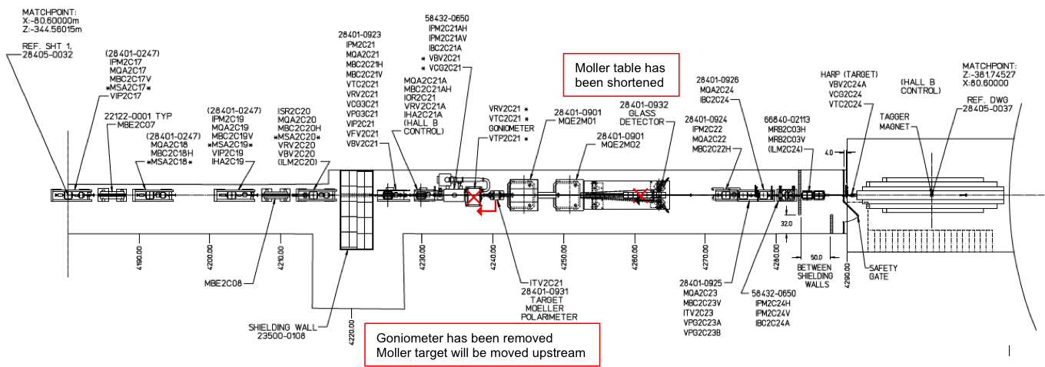

Figure 4 Hall-B beamline: Upstream Tunnel.



Figure 5 Beamline in Hall-B and HPS.